**PROJECT ON SCHOOL MANAGEMENT SYSTEM**

**SQL**

**OBJECTIVE:**

To create a **centralized database system** that simplifies school data management, reduces redundancy, and provides meaningful insights for students, teachers, and administrator.

**SCOPE:**

The scope includes:

1. **Student and Teacher Records**
   * Maintain detailed information about students (personal details, class, contact) and teachers (subjects taught, contact details).
2. **Courses and Subjects**
   * Store information about different courses and the subjects taught, along with teacher assignments.
3. **Class Assignments**
   * Assign students to courses and link teachers with subjects to manage academic relationships.
4. **Attendance and Grades**
   * Track student attendance in each course and record their marks and grades.
5. **Reports on Student Performance**
   * Generate useful reports such as attendance percentage, subject-wise performance, and overall academic results.

**2. TABLES**

**1. students – student_id, name, class, age, gender, contact**

CREATE TABLE students ( student_id INT PRIMARY KEY AUTO_INCREMENT, name VARCHAR(100) NOT NULL, class VARCHAR(20), age INT, gender ENUM('M', 'F', 'Other'), contact VARCHAR(15)

);

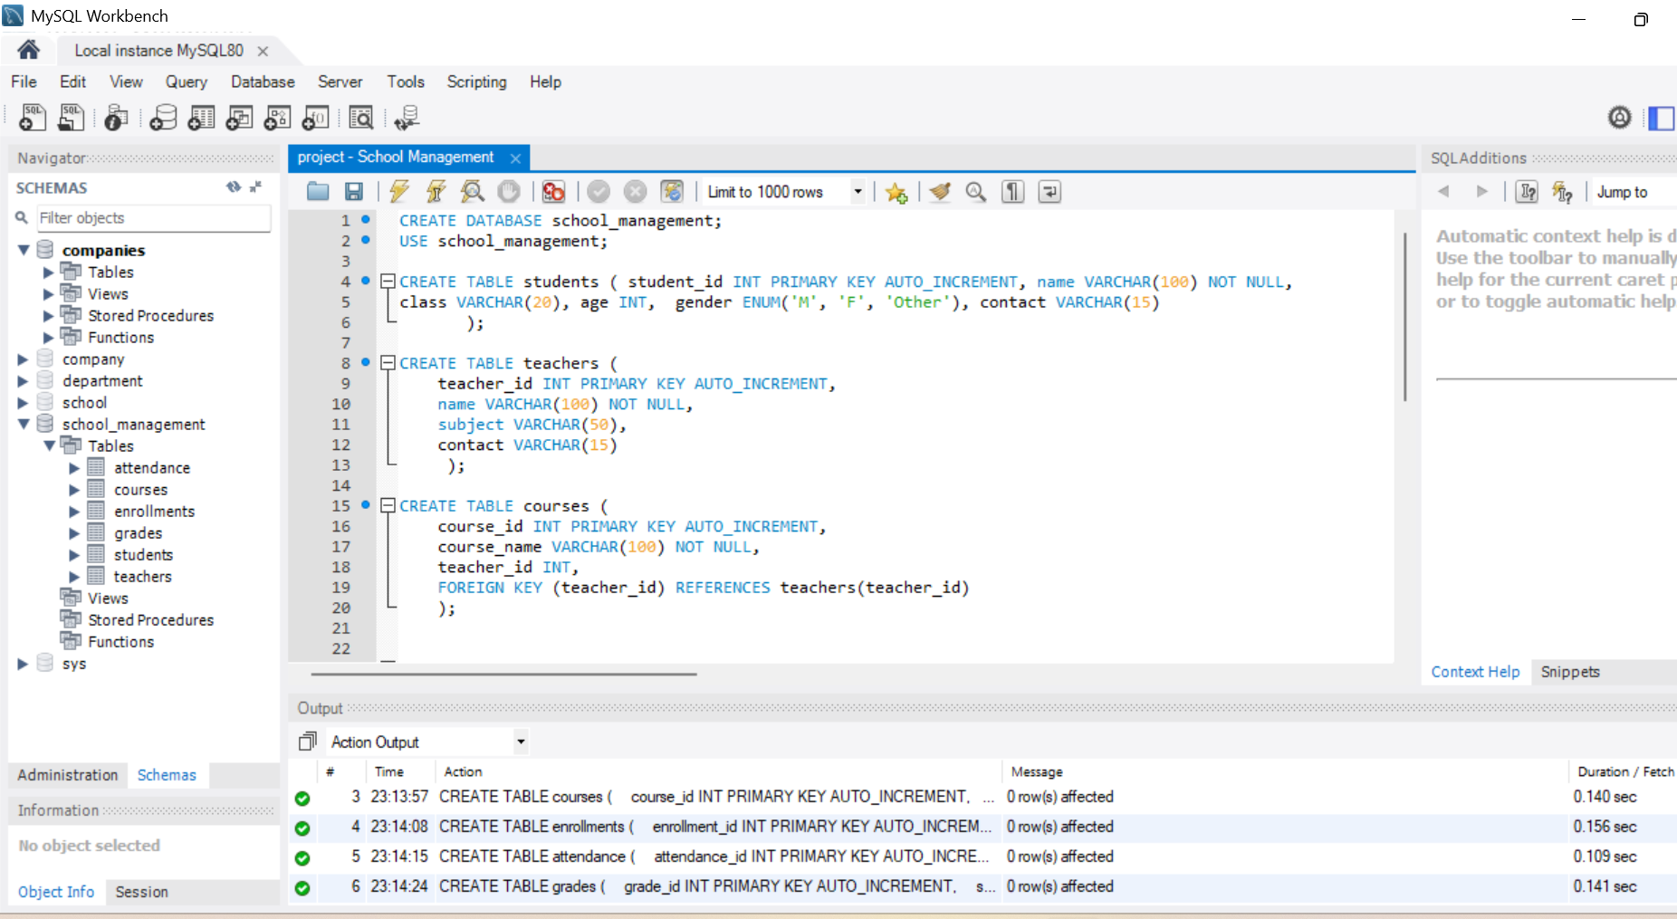

**2. teachers – teacher_id, name, subject, contact**

CREATE TABLE teachers (

teacher_id INT PRIMARY KEY AUTO_INCREMENT,

name VARCHAR(100) NOT NULL,

subject VARCHAR(50),

contact VARCHAR(15)

);

**3.courses – course_id, course_name, teacher_id**

CREATE TABLE courses (

course_id INT PRIMARY KEY AUTO_INCREMENT,

course_name VARCHAR(100) NOT NULL,

teacher_id INT,

FOREIGN KEY (teacher_id) REFERENCES teachers(teacher_id)

);

**4.enrollments – enrollment_id, student_id, course_id, enrollment_date**

CREATE TABLE enrollments (

enrollment_id INT PRIMARY KEY AUTO_INCREMENT,

student_id INT,

course_id INT,

enrollment_date DATE,

FOREIGN KEY (student_id) REFERENCES students(student_id),

FOREIGN KEY (course_id) REFERENCES courses(course_id)

);

**5.attendance – attendance_id, student_id, course_id, date, status**

CREATE TABLE attendance (

attendance_id INT PRIMARY KEY AUTO_INCREMENT,

student_id INT,

course_id INT,

date DATE,

status ENUM('Present', 'Absent', 'Late'),

FOREIGN KEY (student_id) REFERENCES students(student_id),

FOREIGN KEY (course_id) REFERENCES courses(course_id)

);

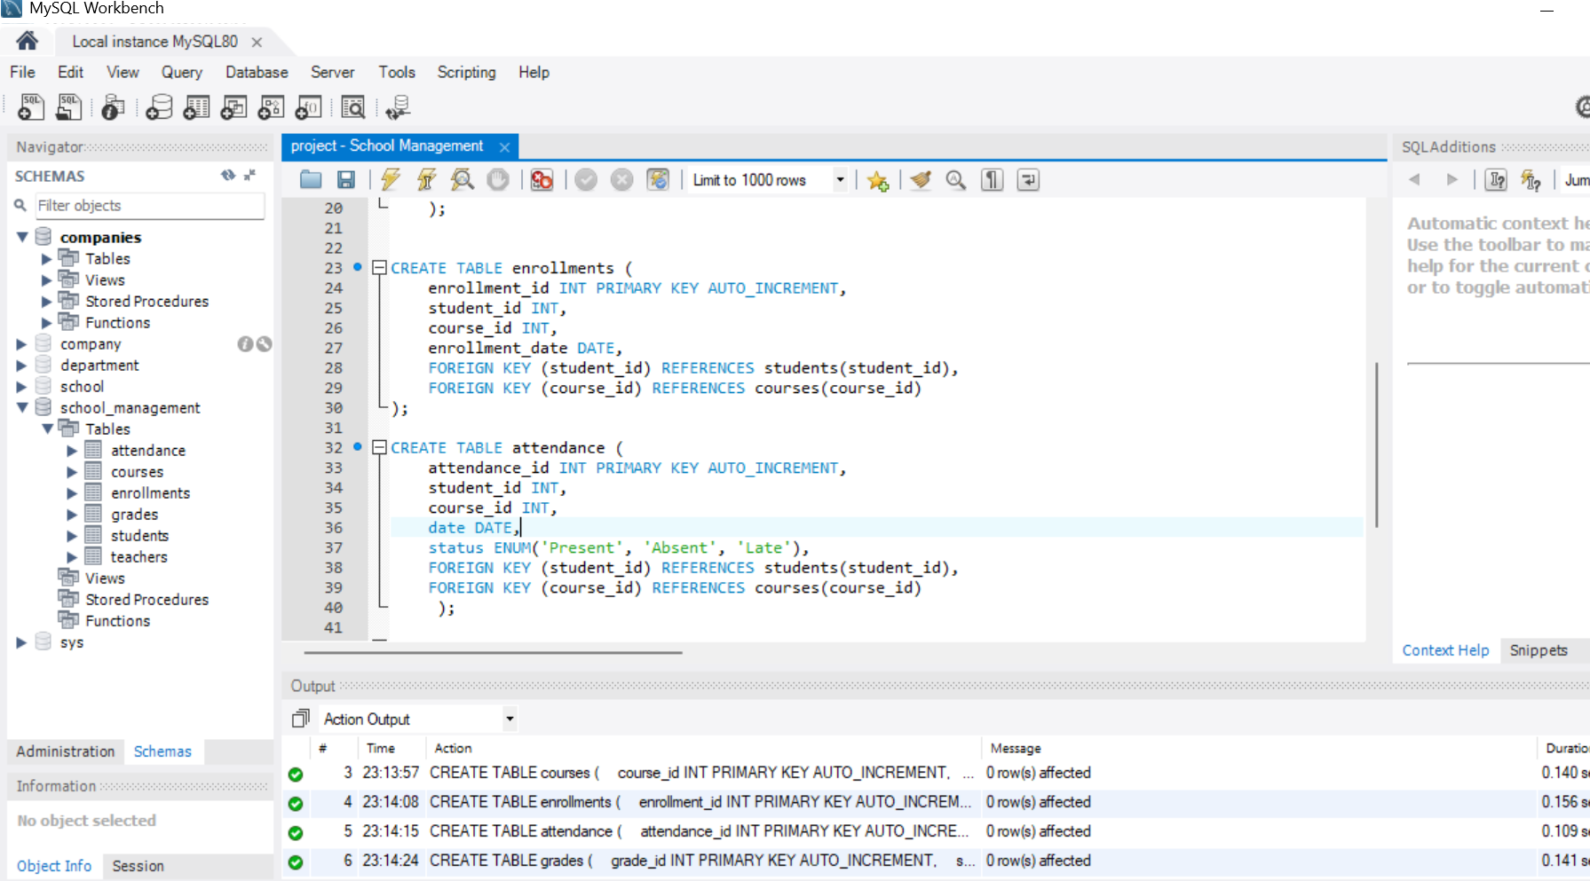

**6.grades – grade_id, student_id, course_id, marks, grade**

CREATE TABLE grades (

grade_id INT PRIMARY KEY AUTO_INCREMENT,

student_id INT,

course_id INT,

marks DECIMAL(5,2),

grade CHAR(2),

FOREIGN KEY (student_id) REFERENCES students(student_id),

FOREIGN KEY (course_id) REFERENCES courses(course_id));

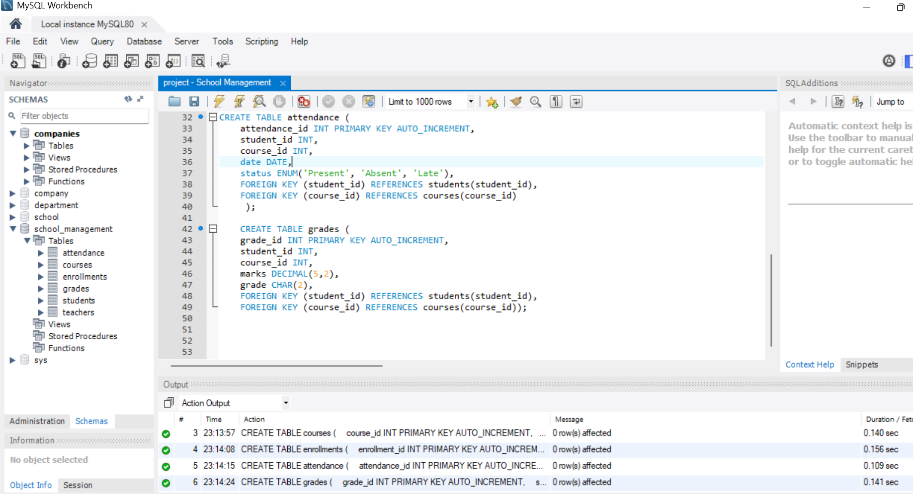

**3. Sample Project Tasks**

**Table Creation & Data Insertion**

1. *Create the students table and insert 10 sample records.*

INSERT INTO students (name, class, age, gender, contact) VALUES

('Rahul Sharma', '10A', 15, 'M', '9876543210'),

('Priya Mehta', '9B', 14, 'F', '9876501234'),

('Amit Verma', '11C', 16, 'M', '9123456789'),

('Sneha Iyer', '12A', 17, 'F', '9345678901'),

('Arjun Reddy', '10B', 15, 'M', '9456789012'),

('Kavya Nair', '9A', 14, 'F', '9567890123'),

('Rohit Gupta', '11A', 16, 'M', '9678901234'),

('Ananya Singh', '12B', 17, 'F', '9789012345'),

('Vikram Das', '10C', 15, 'M', '9890123456'),

('Meera Pillai', '9C', 14, 'F', '9901234567');

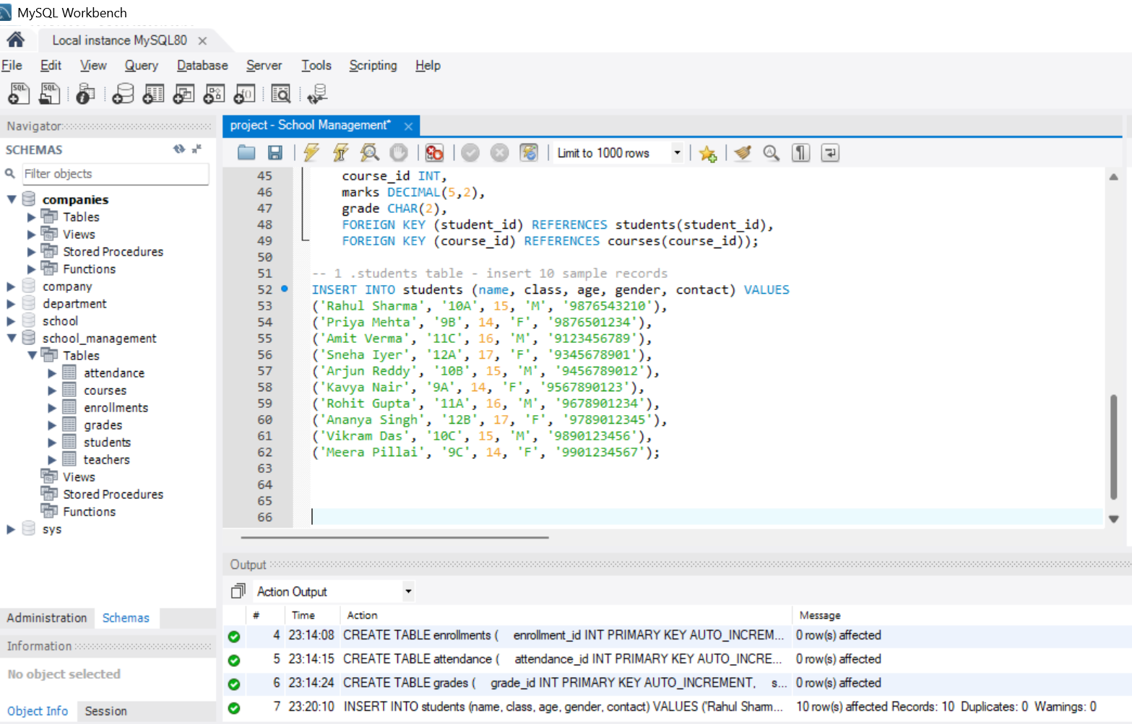

1. *Create the teachers table and insert 5 sample records.*

INSERT INTO teachers (name, subject, contact) VALUES

('Suresh Kumar', 'Mathematics', '9811111111'),

('Anita Sharma', 'English', '9822222222'),

('Ravi Verma', 'Science', '9833333333'),

('Pooja Nair', 'History', '9844444444'),

('Ajay Mehta', 'Computer Science', '9855555555');

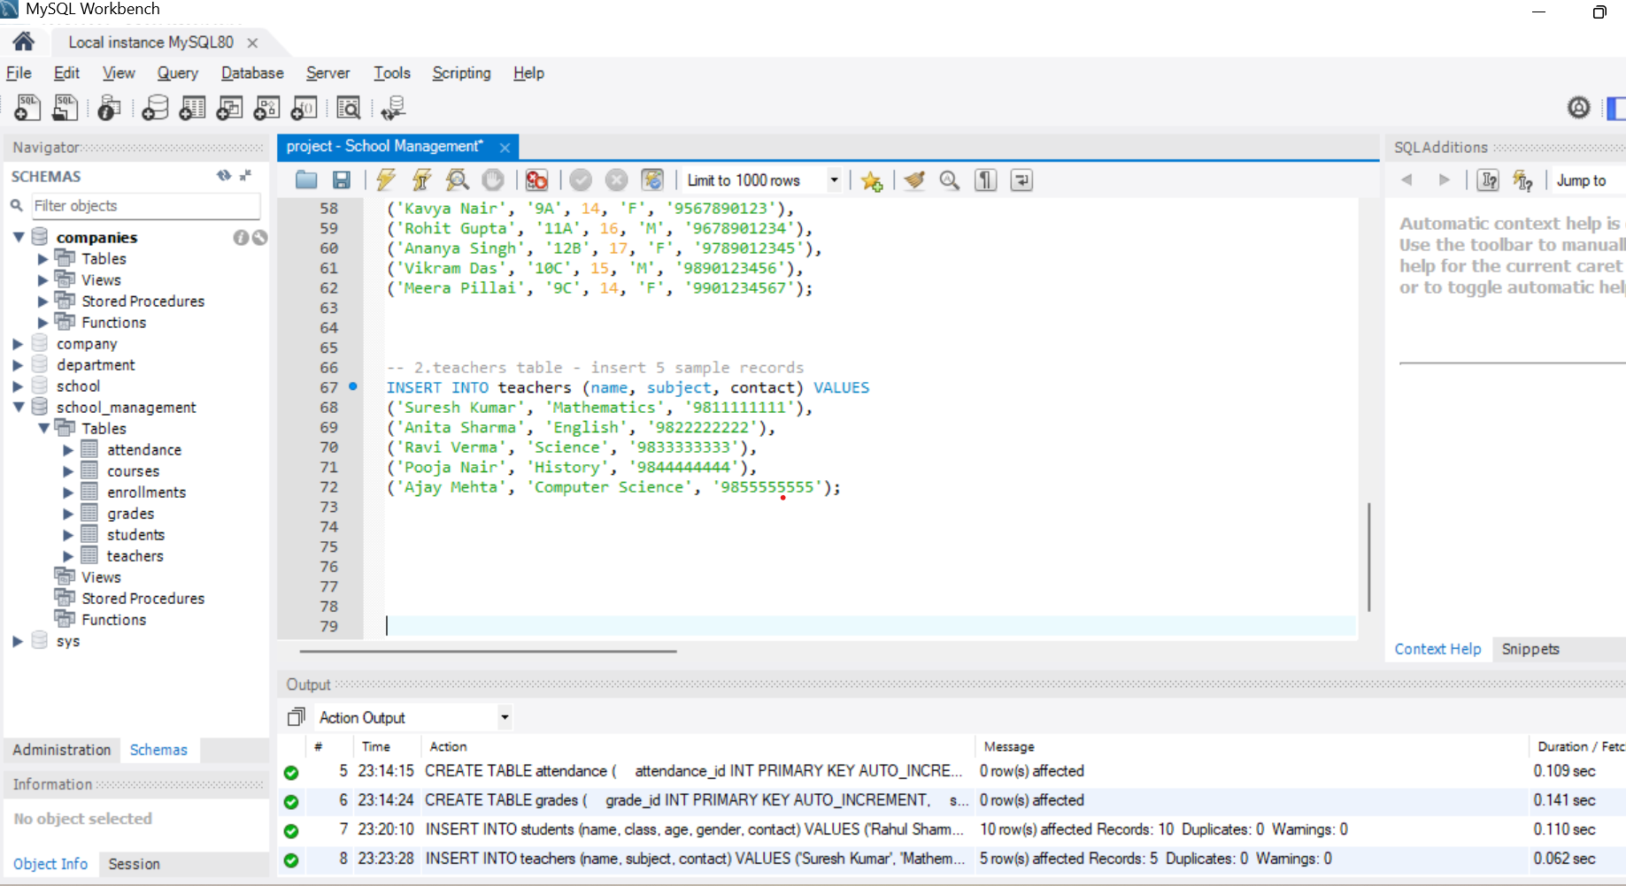

1. *Create the courses table with teacher assignments.*

INSERT INTO courses (course_name, teacher_id) VALUES

('Mathematics - Algebra', 1), ('English Literature', 2),

('Physics', 3), ('World History', 4), ('Computer Programming', 5);

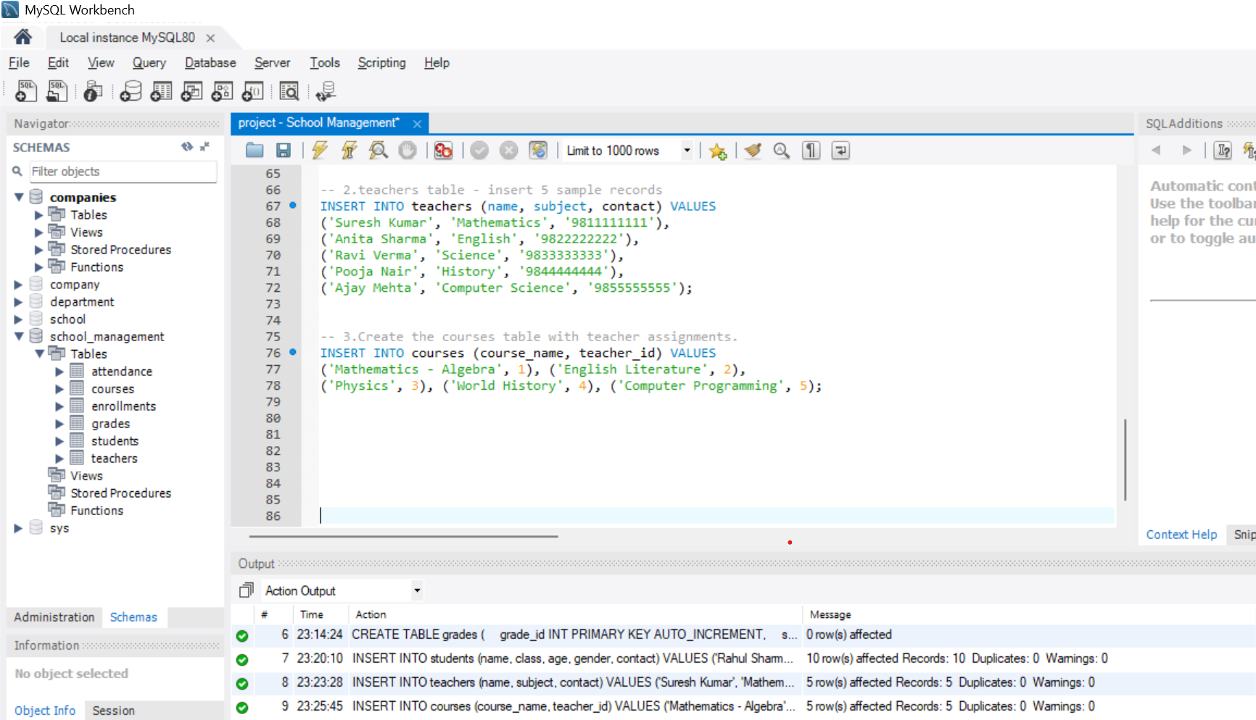

1. *Create the enrollments table and assign students to courses.*

INSERT INTO enrollments (student_id, course_id, enrollment_date) VALUES

(1, 1, '2025-06-01'), --Rahul Sharma → Mathematics - Algebra

(2, 2, '2025-06-02'), --Priya Mehta → English Literature

(3, 3, '2025-06-03'), -- Amit Verma → Physics

(4, 4, '2025-06-04'), -- Sneha Iyer → World History

(5, 5, '2025-06-05'), -- Arjun Reddy → Computer Programming

(6, 1, '2025-06-06'), -- Kavya Nair → Mathematics - Algebra

(7, 3, '2025-06-07'), -- Rohit Gupta → Physics

(8, 2, '2025-06-08'), -- Ananya Singh → English Literature

(9, 5, '2025-06-09'), -- Vikram Das → Computer Programming

(10, 4, '2025-06-10'); -- Meera Pillai → World History

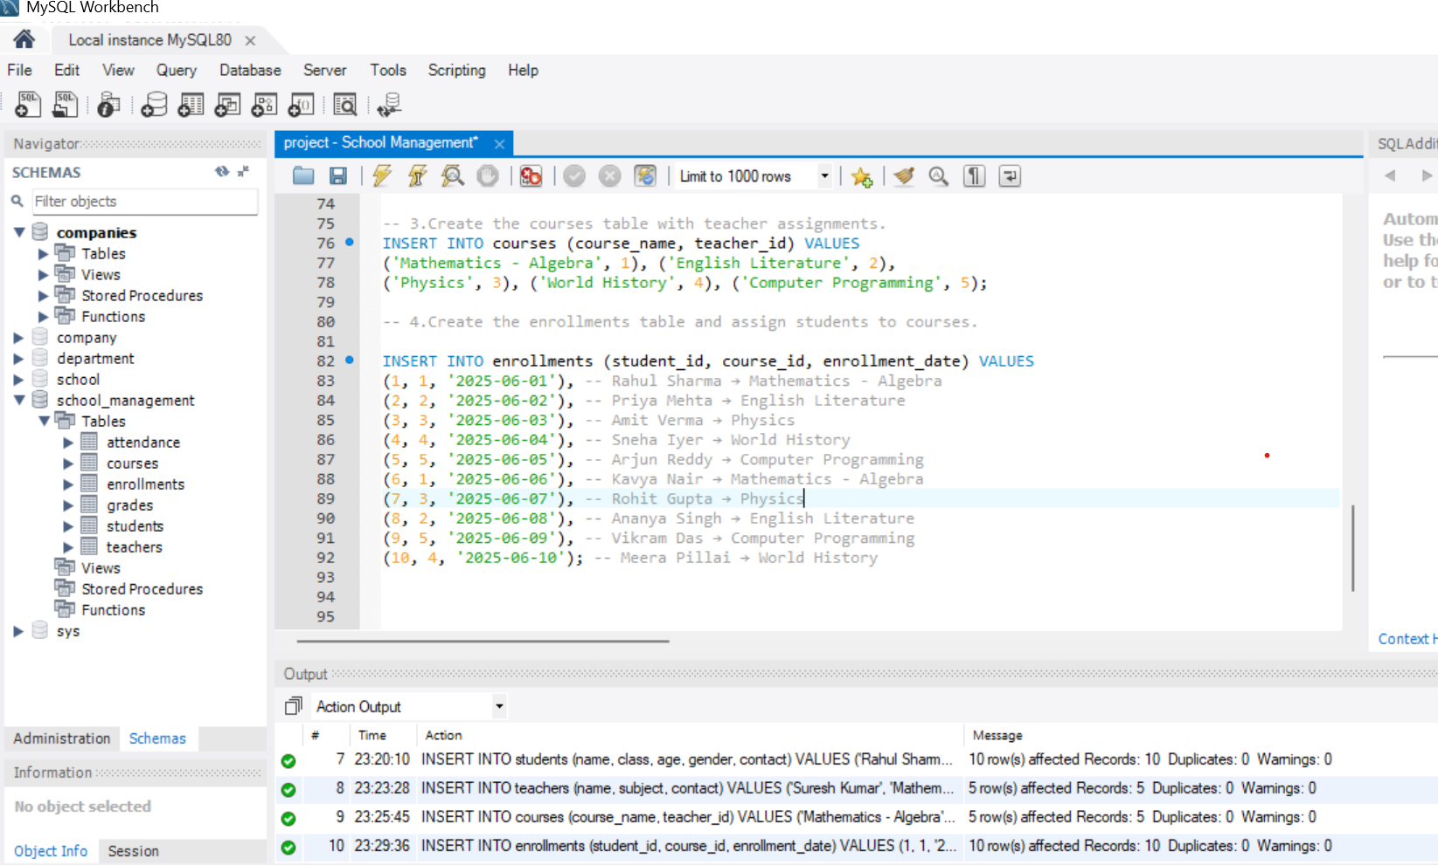

1. *Insert sample attendance data for a month.*

-- Attendance records for August 2025

INSERT INTO attendance (student_id, course_id, date, status) VALUES

-- Rahul Sharma (Student 1) - Mathematics

(1, 1, '2025-08-01', 'Present'),

(1, 1, '2025-08-02', 'Absent'),

(1, 1, '2025-08-03', 'Present'),

(1, 1, '2025-08-04', 'Present'),

-- Priya Mehta (Student 2) - English Literature

(2, 2, '2025-08-01', 'Present'),

(2, 2, '2025-08-02', 'Present'),

(2, 2, '2025-08-03', 'Late'),

(2, 2, '2025-08-04', 'Present'),

-- Amit Verma (Student 3) - Physics

(3, 3, '2025-08-01', 'Absent'),

(3, 3, '2025-08-02', 'Present'),

(3, 3, '2025-08-03', 'Present'),

(3, 3, '2025-08-04', 'Present'),

-- Sneha Iyer (Student 4) - World History

(4, 4, '2025-08-01', 'Present'),

(4, 4, '2025-08-02', 'Present'),

(4, 4, '2025-08-03', 'Present'),

(4, 4, '2025-08-04', 'Absent'),

-- Arjun Reddy (Student 5) - Computer Programming

(5, 5, '2025-08-01', 'Late'),

(5, 5, '2025-08-02', 'Present'),

(5, 5, '2025-08-03', 'Present'),

(5, 5, '2025-08-04', 'Present');  
  
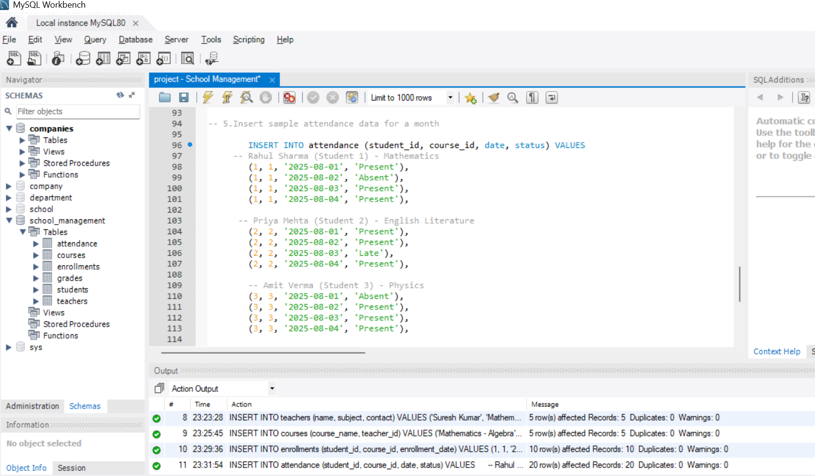

**Basic Queries:**

1. *List all students in a particular class*

SELECT student_id, name, class, age, gender, contact

FROM students

WHERE class = '10A';

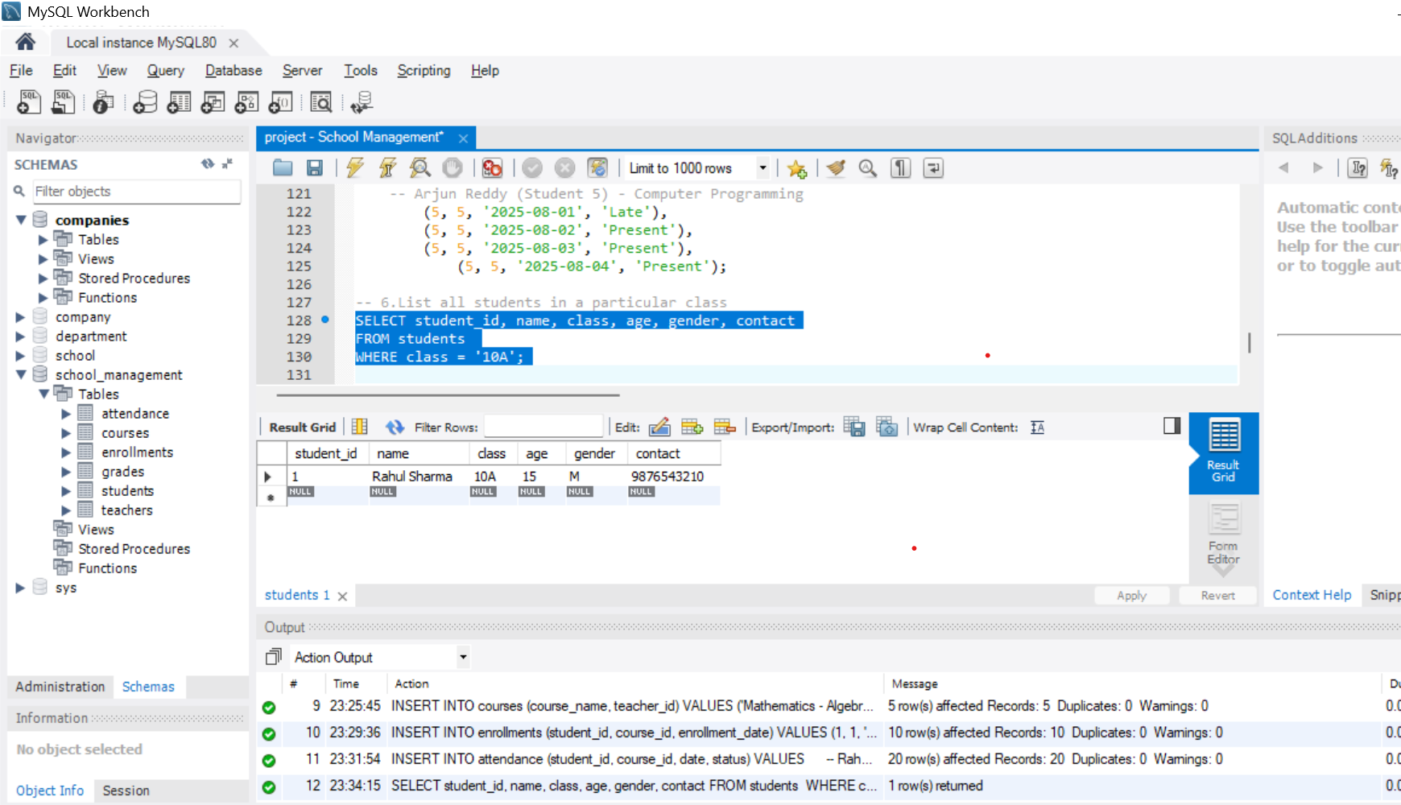

1. *Show all teachers and their subjects.*

SELECT teacher_id, name AS teacher_name, subject

FROM teachers;

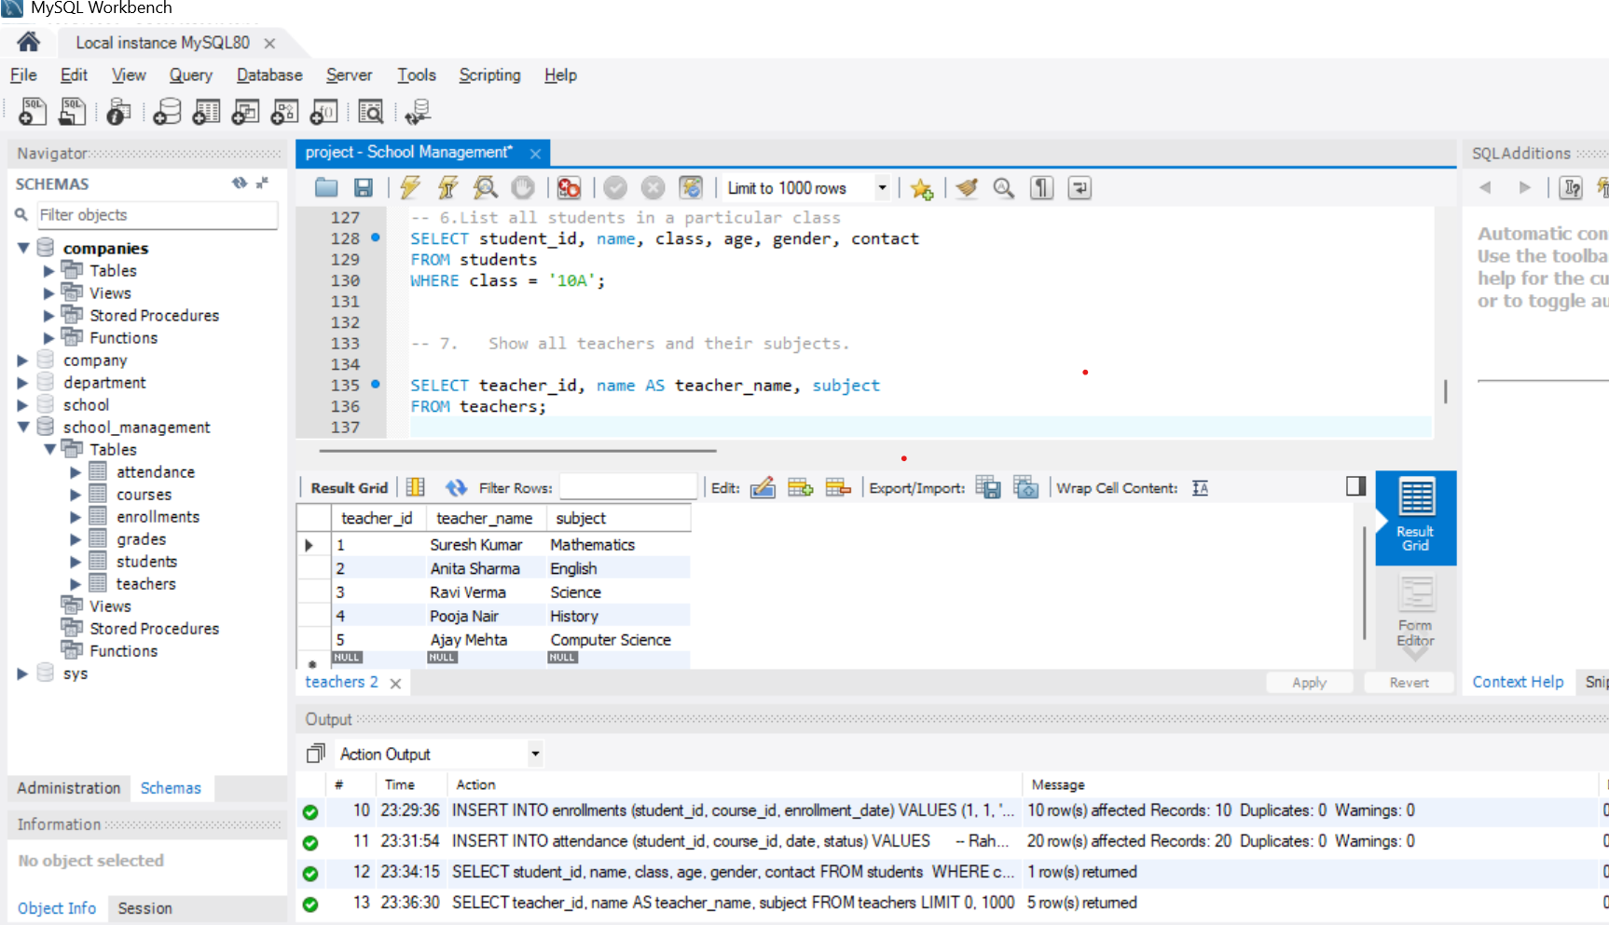

1. *Display all courses and assigned teachers.*

SELECT

c.course_id,

c.course_name,

t.name AS teacher_name,

t.subject

FROM courses c

JOIN teachers t ON c.teacher_id = t.teacher_id;

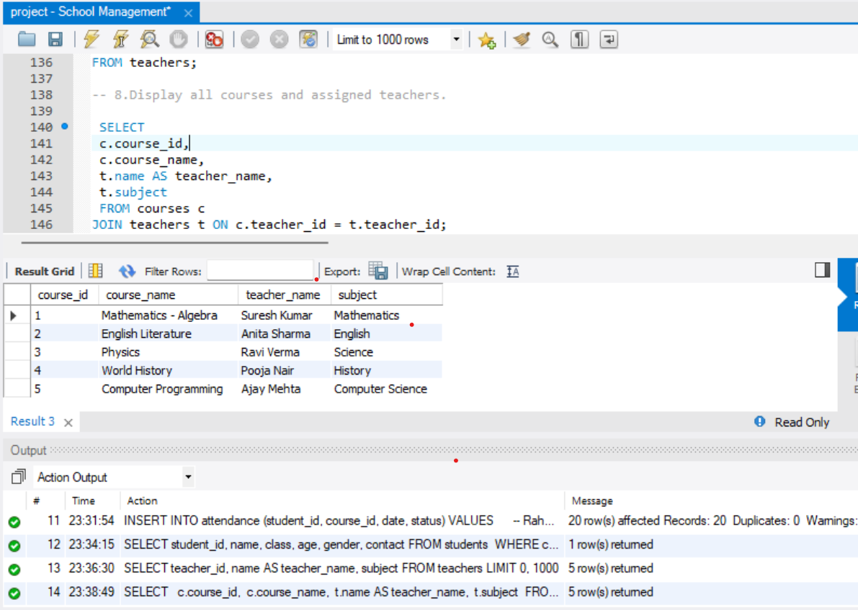

1. *Find students enrolled in a specific course.*

SELECT

s.student_id,

s.name AS student_name, s.class,

c.course_name

FROM students s

JOIN enrollments e ON s.student_id = e.student_id

JOIN courses c ON e.course_id = c.course_id

WHERE c.course_name = 'Physics';

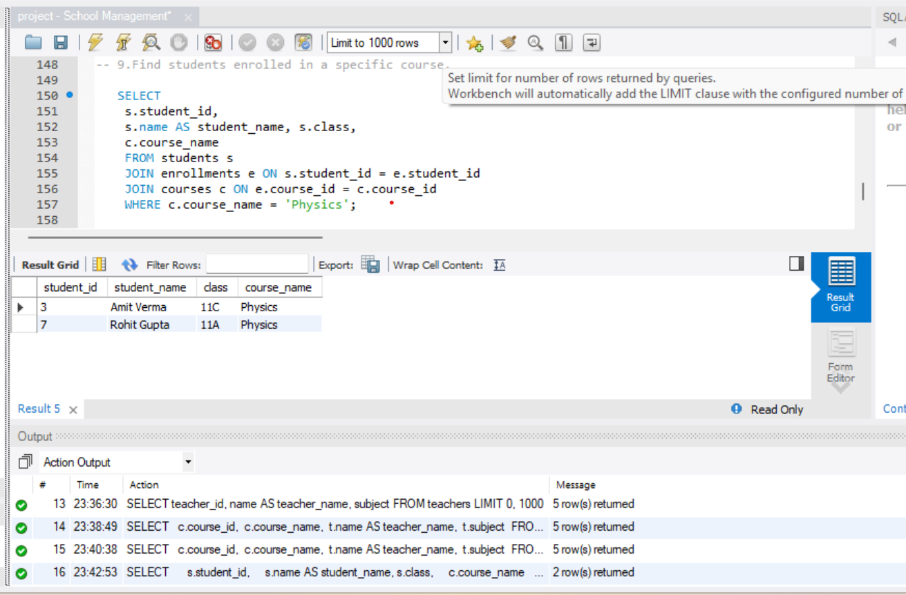

1. *Show attendance records for a particular student.*

SELECT

s.student_id,

s.name AS student_name,

c.course_name,

a.date,

a.status

FROM attendance a

JOIN students s ON a.student_id = s.student_id

JOIN courses c ON a.course_id = c.course_id

WHERE s.student_id = 1

ORDER BY a.date ;

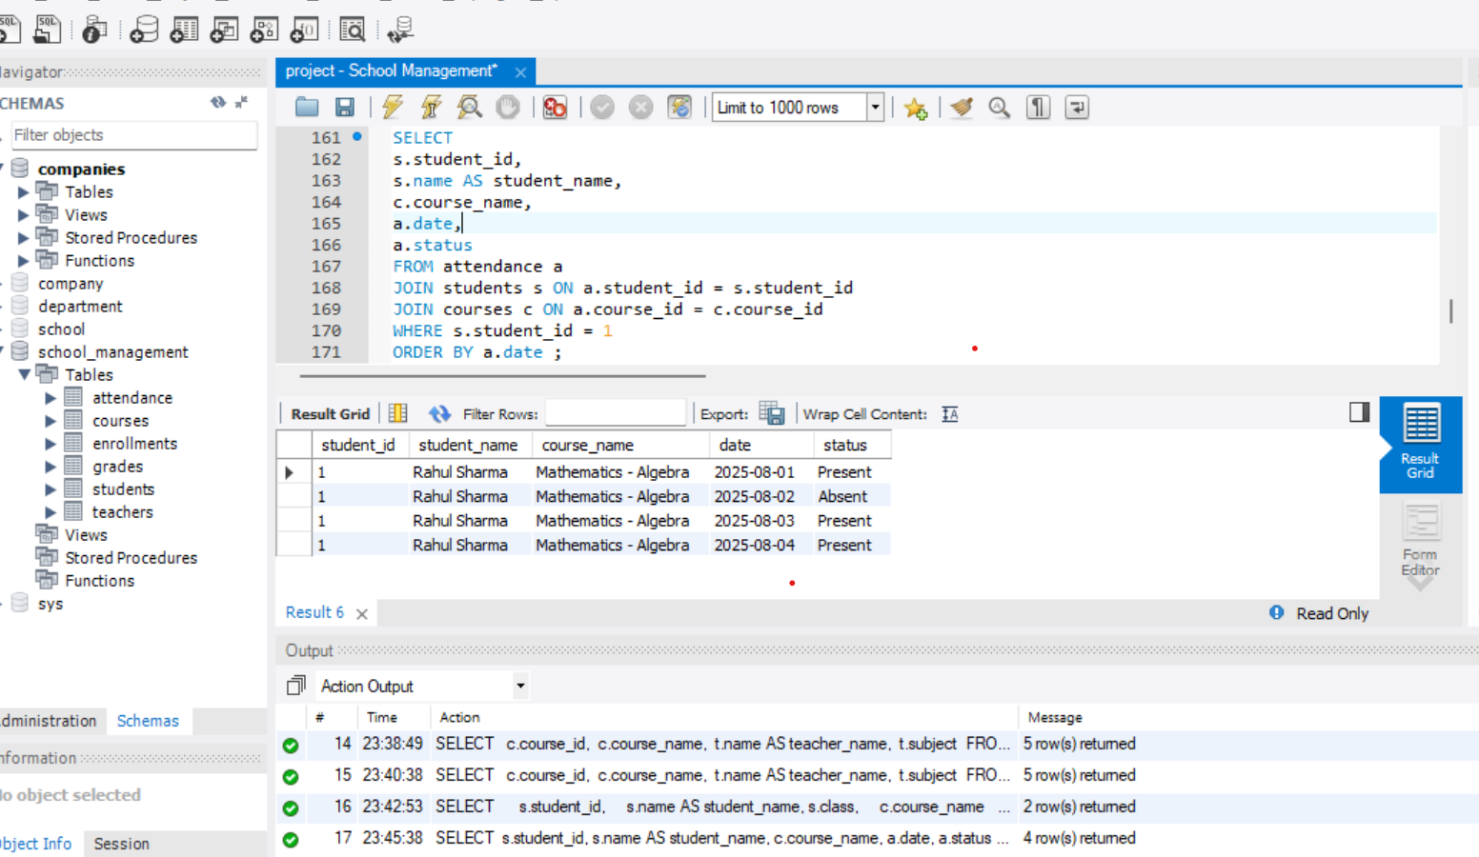

**Intermediate Queries:**

1. *Count total students enrolled in each course.*

SELECT

c.course_id,

c.course_name,

COUNT(e.student_id) AS total_students

FROM courses c

LEFT JOIN enrollments e ON c.course_id = e.course_id

GROUP BY c.course_id, c.course_name;

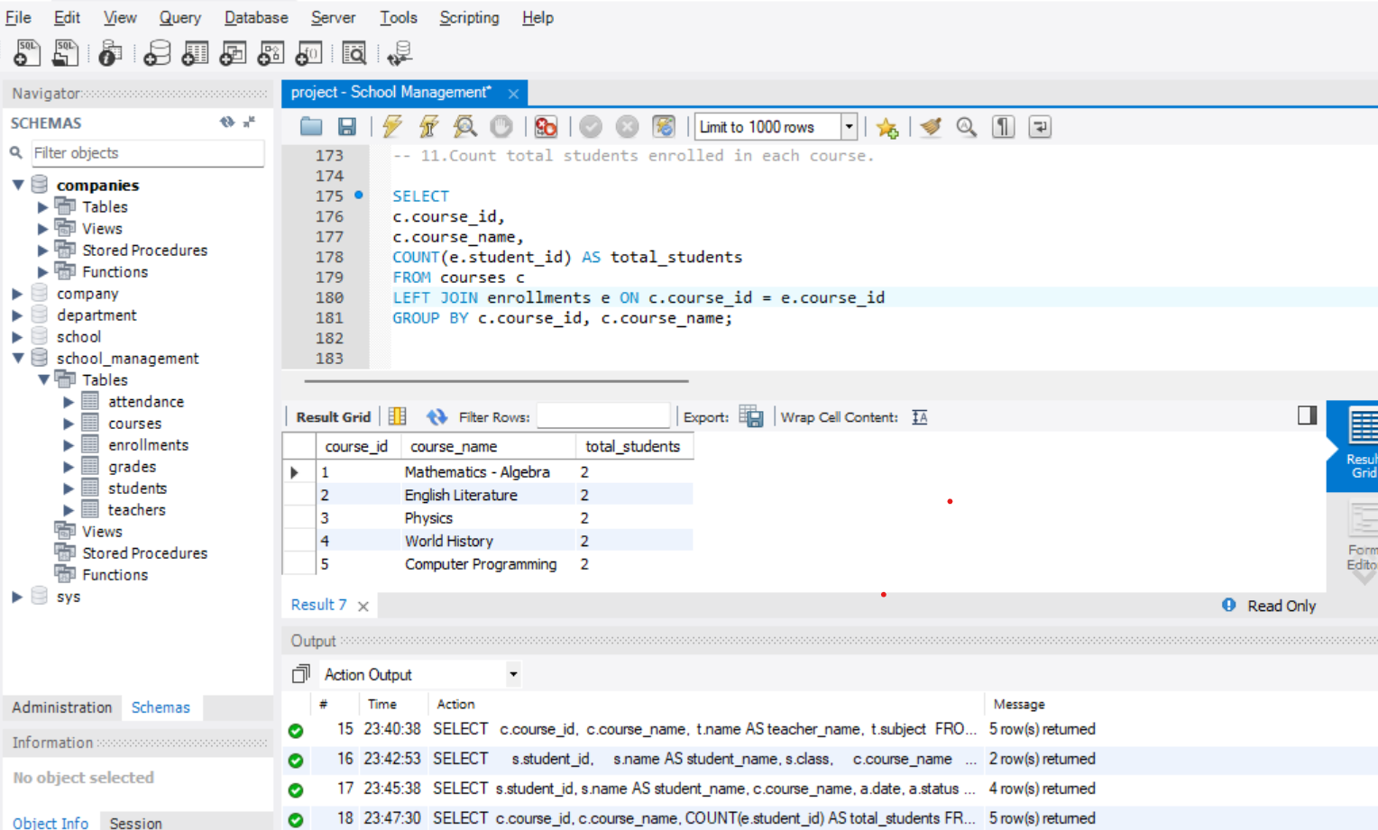

1. *List students with attendance below 75%.*

SELECT

s.student_id,

s.name AS student_name,

COUNT(a.attendance_id) AS total_classes,

SUM(CASE WHEN a.status = 'Present' THEN 1 ELSE 0 END) AS present_days,

ROUND((SUM(CASE WHEN a.status = 'Present' THEN 1 ELSE 0 END) * 100.0 /

COUNT(a.attendance_id)), 2) AS attendance_percentage

FROM students s

JOIN attendance a ON s.student_id = a.student_id

GROUP BY s.student_id, s.name

HAVING attendance_percentage < 75;

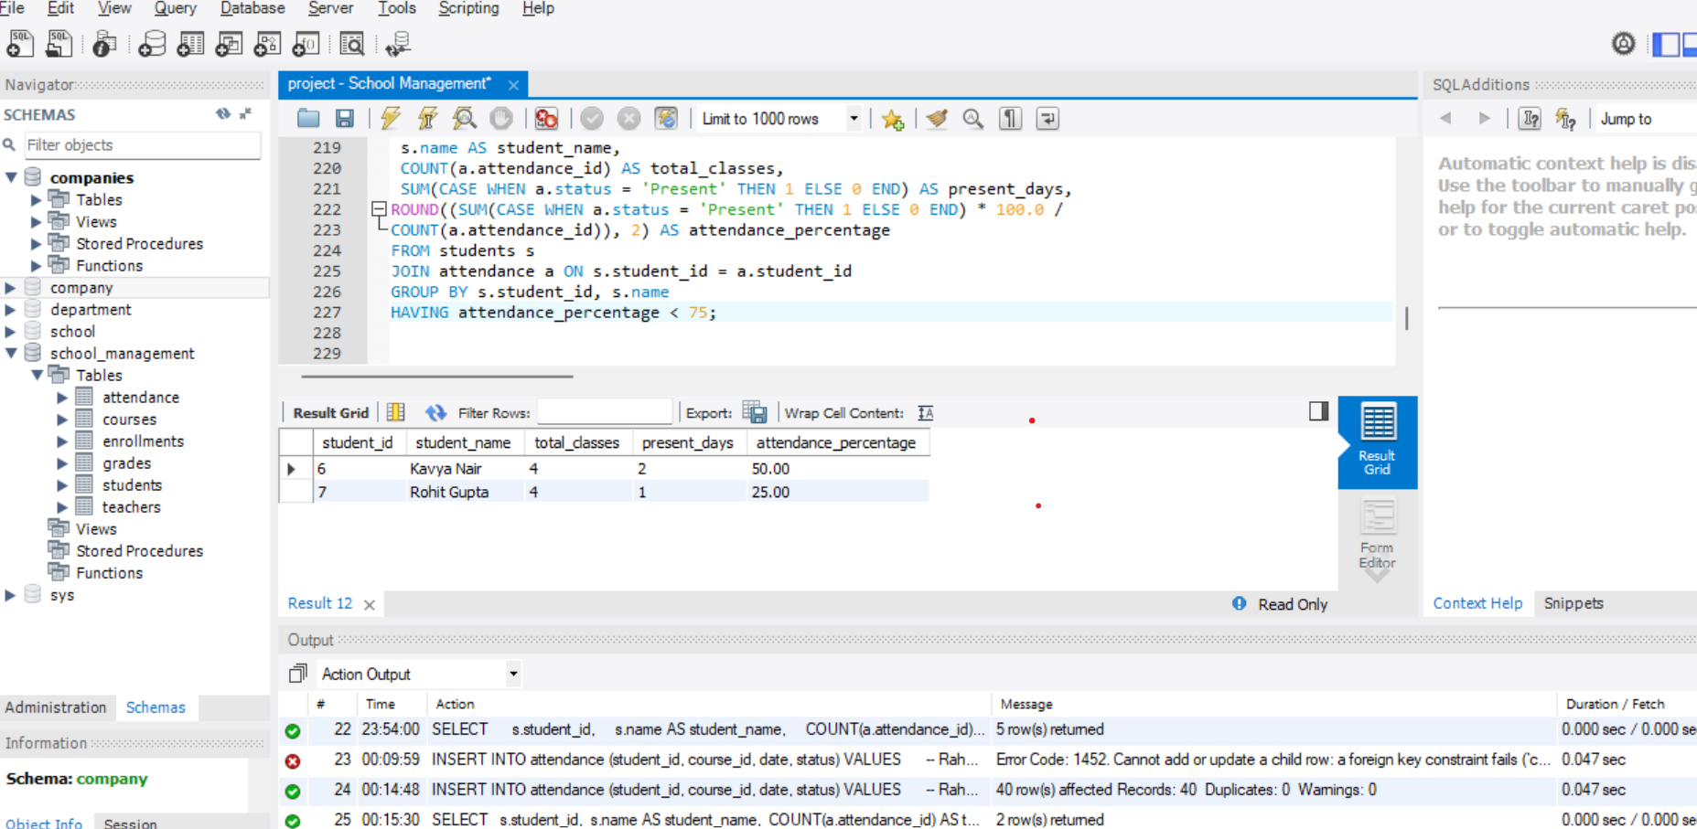

1. *Find the average grade of each student across courses.*

SELECT

s.student_id,

s.name AS student_name,

c.course_name,

ROUND(AVG(g.marks), 2) AS average_marks

FROM students s

JOIN grades g ON s.student_id = g.student_id

JOIN courses c ON g.course_id = c.course_id

GROUP BY s.student_id, s.name, c.course_name

ORDER BY s.student_id, c.course_name;

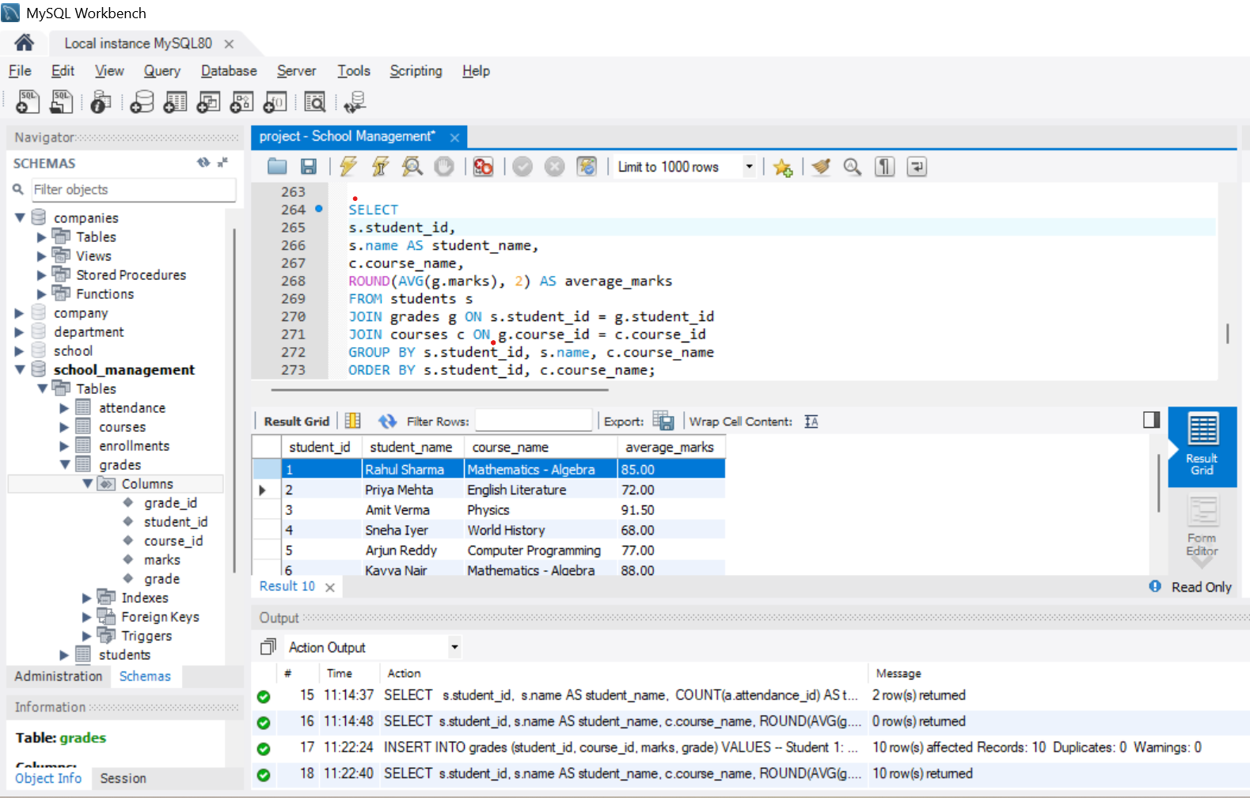

1. *Show students who scored above 90 in any course.*

SELECT

s.student_id,

s.name AS student_name,

c.course_name,

g.marks

FROM grades g

JOIN students s ON g.student_id = s.student_id

JOIN courses c ON g.course_id = c.course_id

WHERE g.marks > 90

ORDER BY g.marks DESC;

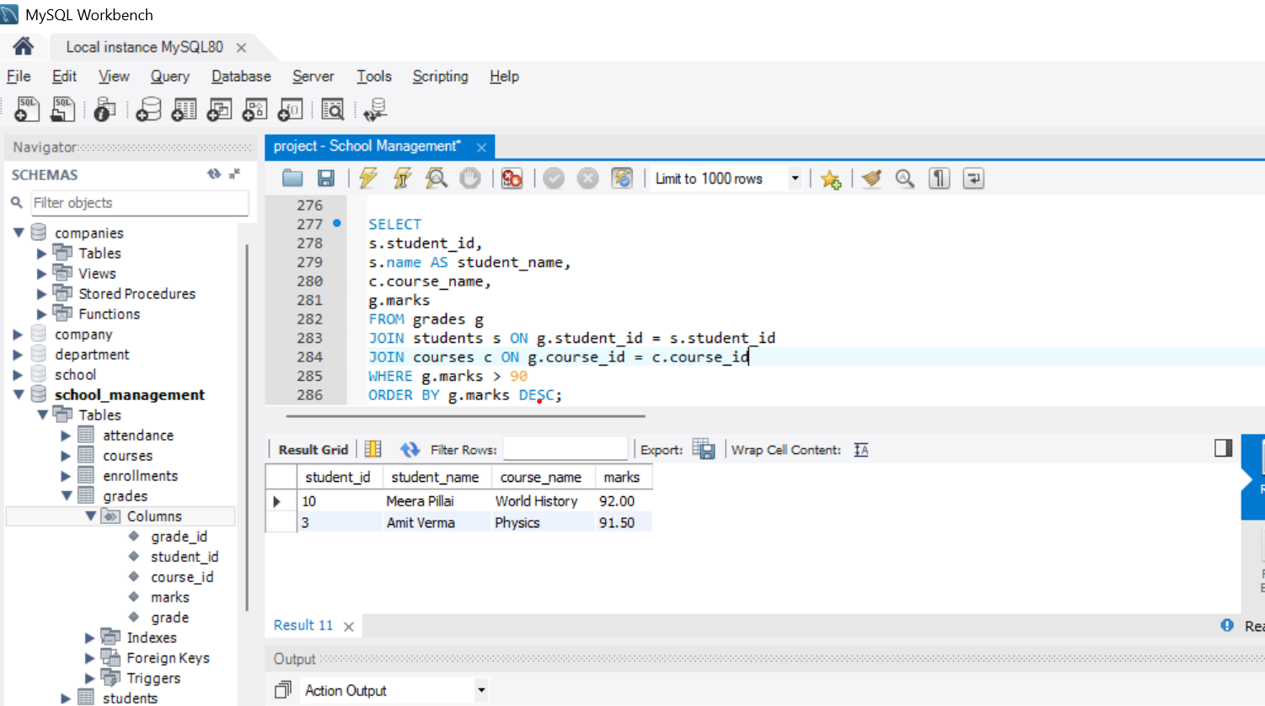

1. *Display all courses taught by a specific teacher.*

SELECT

c.course_id,

c.course_name,

t.name AS teacher_name,

t.subject

FROM courses c

JOIN teachers t ON c.teacher_id = t.teacher_id

WHERE t.name = 'Suresh Kumar';

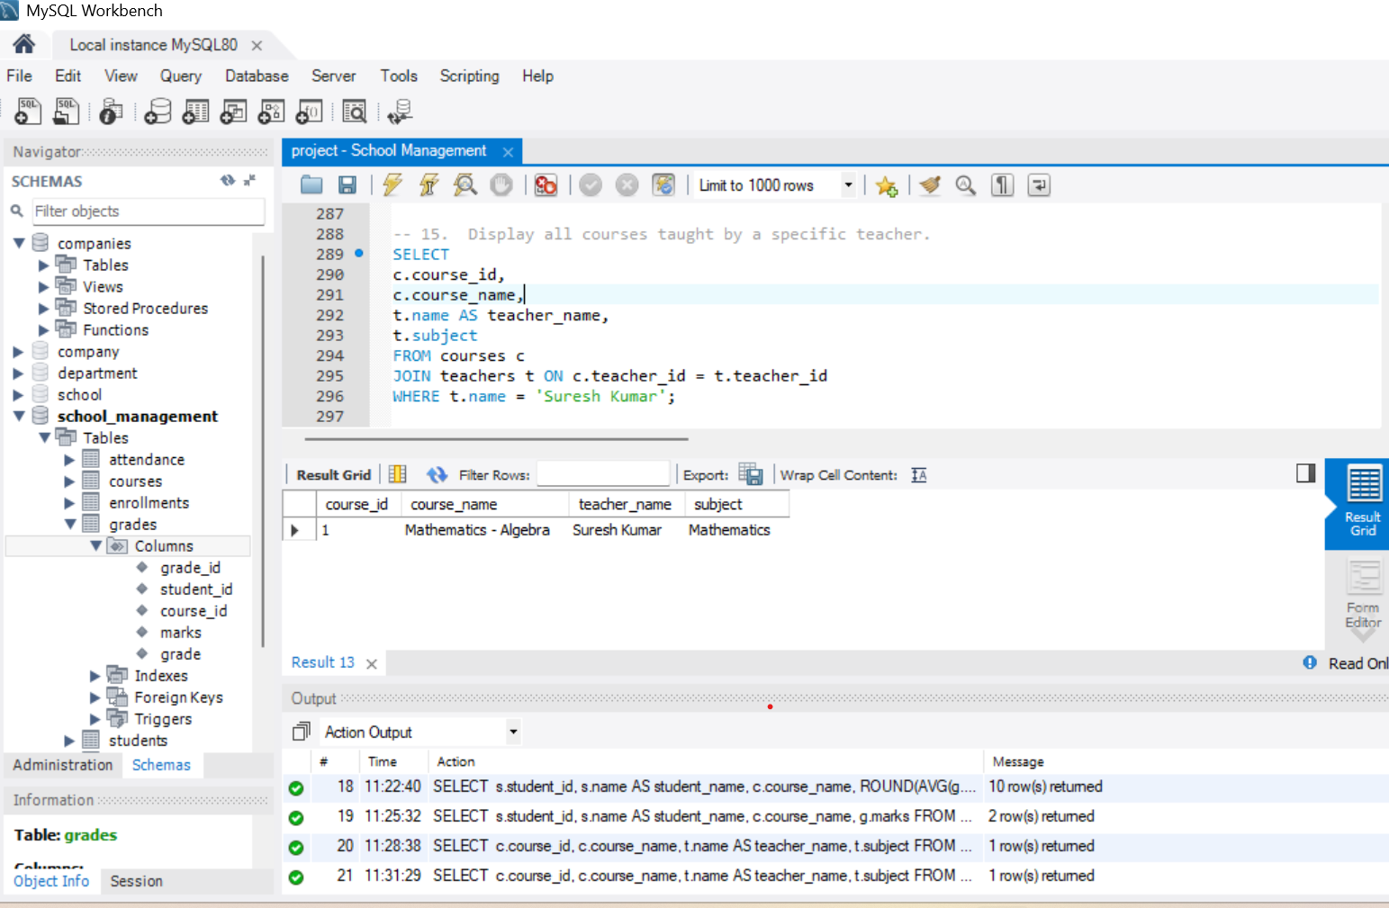

**Advanced Features**

1. *Create a view student_performance showing student name, course, and grade.*

CREATE VIEW student_performance AS

SELECT

s.student_id,

s.name AS student_name,

c.course_name,

g.marks,

g.grade

FROM students s

JOIN grades g ON s.student_id = g.student_id

JOIN courses c ON g.course_id = c.course_id;

**SELECT * FROM student_performance;**

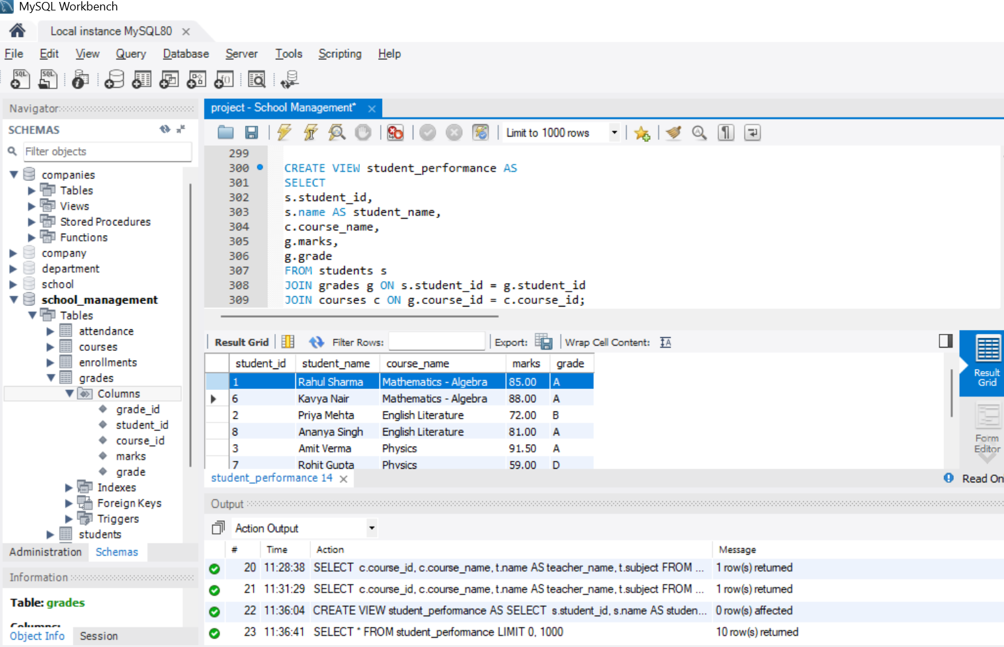

1. *Write a stored procedure to update a student’s grade.*

DELIMITER $$

CREATE PROCEDURE update_student_grade (

IN p_student_id INT,

IN p_course_id INT,

IN p_marks DECIMAL(5,2),

IN p_grade VARCHAR(2)

)

BEGIN

UPDATE grades

SET marks = p_marks,

grade = p_grade

WHERE student_id = p_student_id

AND course_id = p_course_id;

END $$

DELIMITER;

**CALL update_student_grade(1, 101, 95, 'A');**

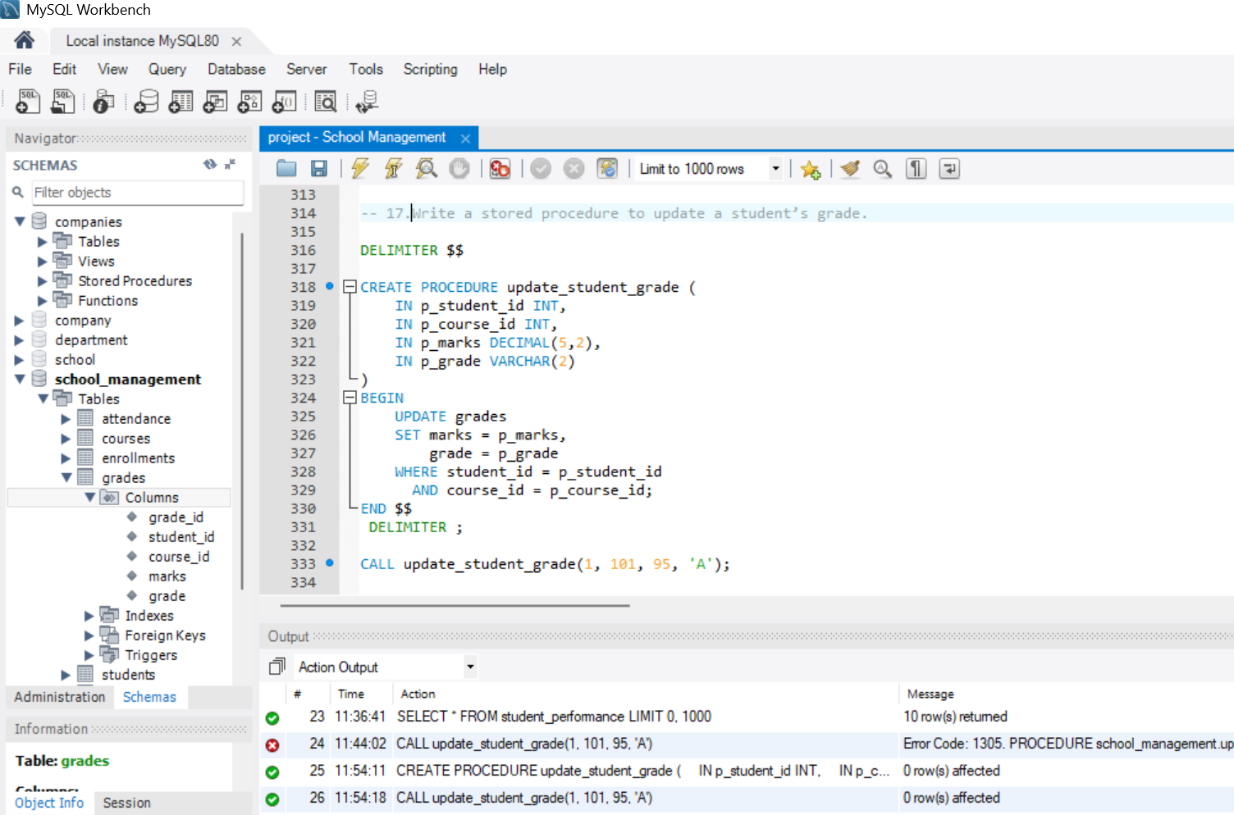

1. *Create a trigger to mark attendance automatically when a student is enrolled in a course.*

DELIMITER $$

CREATE TRIGGER after_enrollment_insert

AFTER INSERT ON enrollments

FOR EACH ROW

BEGIN

-- Insert an initial attendance record for the enrollment date

INSERT INTO attendance (student_id, course_id, date, status)

VALUES (NEW.student_id, NEW.course_id, NEW.enrollment_date, ‘Present’);

END $$

DELIMITER;

**INSERT INTO enrollments (enrollment_id, student_id, course_id, enrollment_date)**

**VALUES (21, 3, 2, '2025-09-03');**

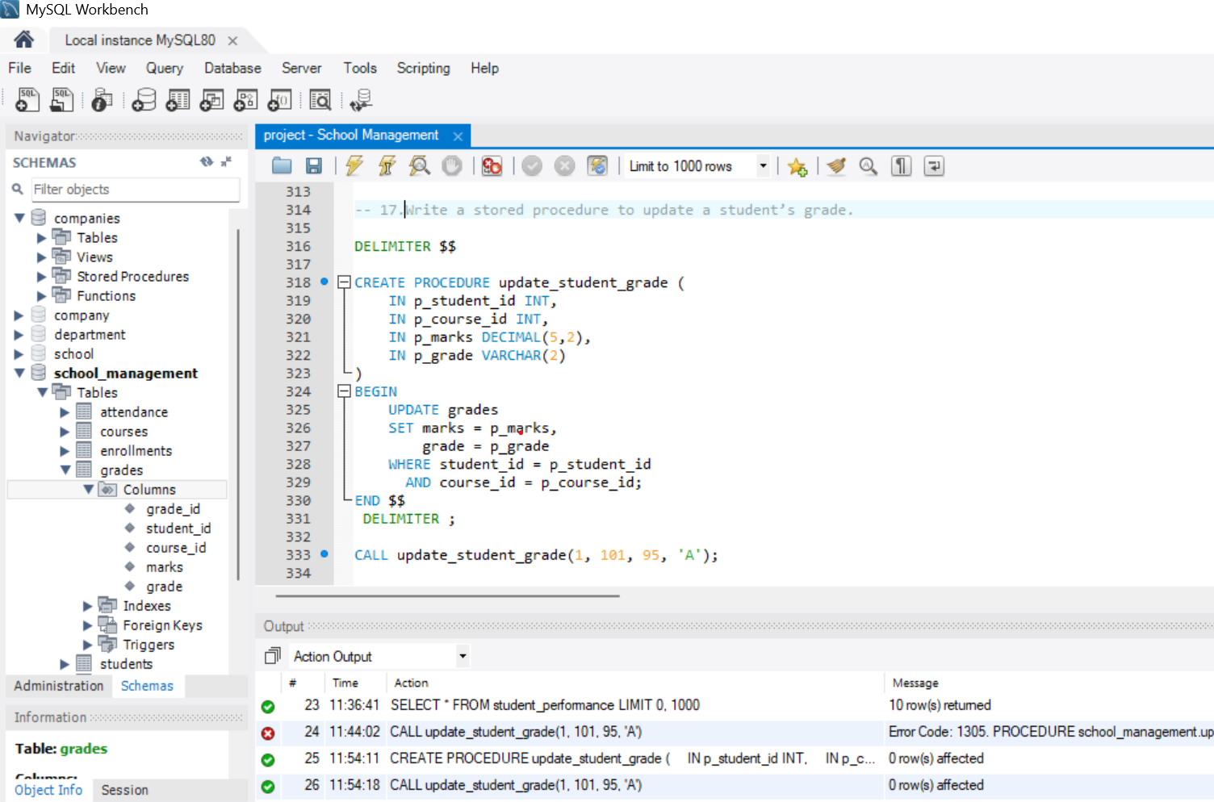

1. *Generate a report showing top-performing students in each class.*

WITH student_avg AS (

SELECT

s.student_id,

s.name AS student_name,

s.class,

ROUND(AVG(g.marks), 2) AS avg_marks

FROM students s

JOIN grades g ON s.student_id = g.student_id

GROUP BY s.student_id, s.name, s.class)

SELECT sa.class, sa.student_id, sa.student_name, sa.avg_marks

FROM student_avg sa

WHERE sa.avg_marks = (

SELECT MAX (avg_marks)

FROM student_avg

WHERE class = sa.class)

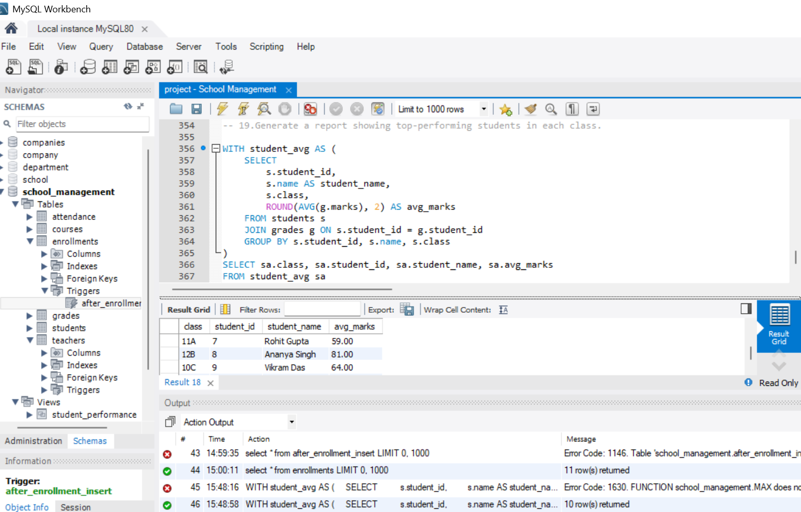

1. *Write a query to find the teacher handling the most courses.*

SELECT

t.teacher_id,

t.name AS teacher_name,

COUNT(c.course_id) AS total_courses

FROM teachers t

JOIN courses c ON t.teacher_id = c.teacher_id

GROUP BY t.teacher_id, t.name

ORDER BY total_courses DESC;

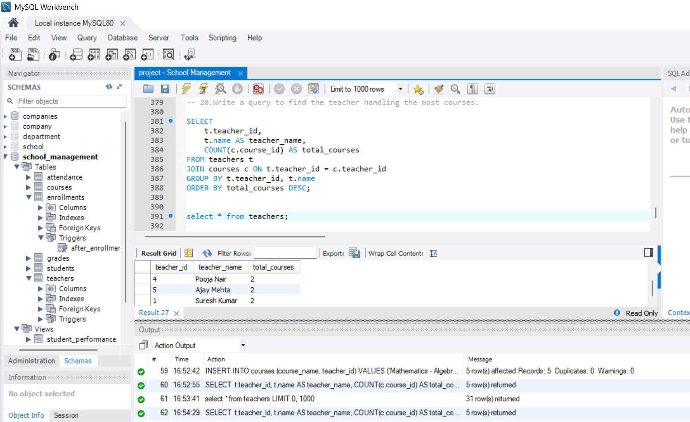

**✅ Conclusion**

The **School Management System database** effectively demonstrates how relational databases can be used to manage real-world school operations. It integrates **students, teachers, courses, enrollments, attendance, and grades** into a single structured system.

With SQL queries, schools can:

* Monitor **attendance** trends.
* Track **student performance**.
* Optimize **teacher assignments**.